**Computer Graphics Assignment**

**1a)** A variable that is set to attribute is a global variable that can vary between vertex to vertex. A variable that is set to uniform on the other hand can vary from pixel to pixel. A variable that is labelled varying can be used in both the vertex shader and the fragment shader.

**1b) From Directional lighting by Frederick Li**

var verticesColors = new Float32Array([

-10.0, 0.0, 5.0, 1.0, 1.0, 1.0, // (x,y,z), (r,g,b)

10.0, 0.0, 0.0, 1.0, 0.5, 1.0,

0.0, 10.0, 0.0, 1.0, 1.0, 0.4,

0.0, -20.0, 0.0, 0.5, 1.0, 1.0,

3.0, 0.0, -20.0, 1.0, 1.0, 0.5,

0.0, 0.0, 20.0, 0.25, 1.0, 1.0

]);

var n = 6;

var vertexColorBuffer = gl.createBuffer();

if (!vertexColorBuffer) {

console.log('Failed to create the buffer object');

return false;

}

gl.bindBuffer(gl.ARRAY_BUFFER, vertexColorBuffer);

gl.bufferData(gl.ARRAY_BUFFER, verticesColors, gl.STATIC_DRAW);

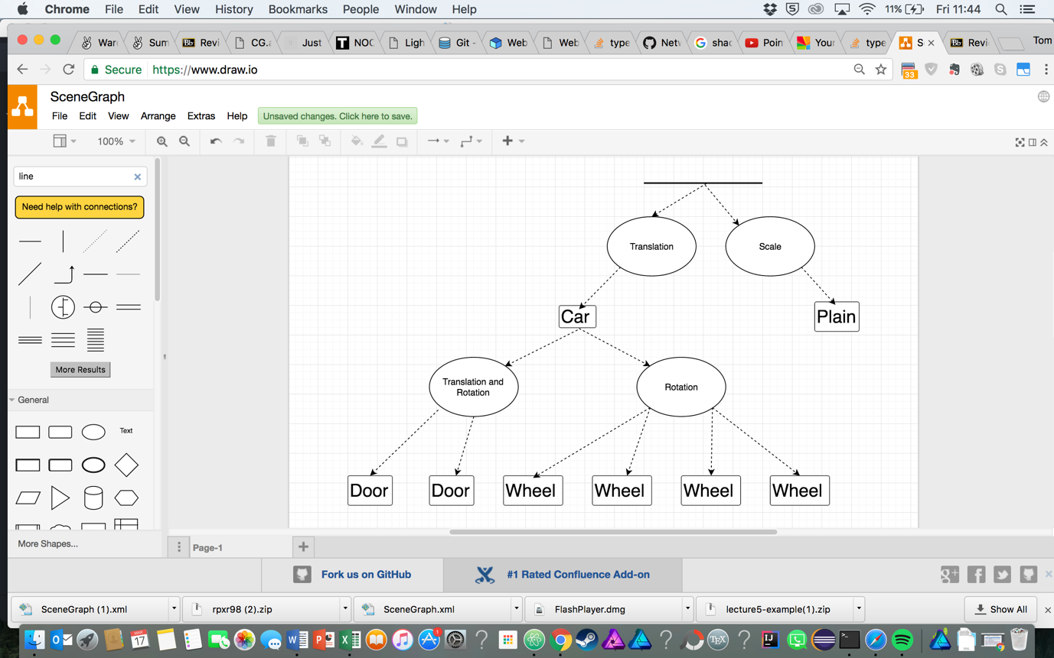**1c)**

**1di)** The code will draw a box that is translated 1 along the x axis, 3 up the y axis and then -5 on the z axis which is then rotated around the y axis and at point x=0,z=0 by the angle.

**1dii)** If the transformations on the object are only the transformations shown in the question, there will be no difference between setRotate and rotate but if there are transformations before it there will be a difference. This is because setRotate changes the transformation matrix to the rotation matrix while rotate applies the rotation transformation to the current transformation matrix.